Account Validation

The Account Validation API is intended to confirm that target accounts are valid so that payments can be posted as desired. Select the API product you want to test:

ACH Credit Account Validation
ACH Debit Account Validation

ACH Credit Account Validation

Account Validation test data is provided below with a variety of realistic account information. This data has been preloaded into the sandbox and should all return a successful account validation outcome of 200 – Enabled or 200 – Disabled or 200 – Unable to Locate / 404 – Not Found if used correctly in the API.

Account Validation API Test Data for Creditor Account
Member Identification  [Bank ID/ABA RTN] | Creditor or Debtor identification  [Account Number] | Account Type | Account Accepts | Account Status
061103852 | 11101011 | Current | Credits | 200- Enabled
061103852 | 11101013 | Current | Credits | 200-Enabled
061103852 | 11101015 | Current | Credits and Debit | 200-Enabled
061103852 | 11101016 | Savings | Credits and Debits | 200-Enabled
061103852 | 11101017 | Current | Credits | 200-Disabled
061103852 | 11101019 | Savings | Credits and Debits | 404 – Not Found
NOTE: Mandatory field clearingSystemIdentification should be set to “USABA”.

Resource URL

Resource URL has been preset for each Account Validation API.

Header Parameter

An optional Request_Id may be inserted for tracing purposes.

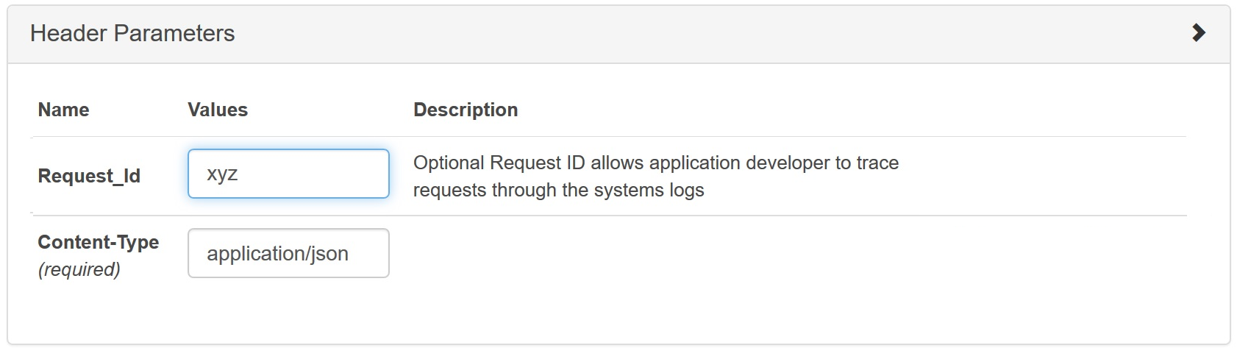

Also, remember to set the apikey before sending the API request.

Request Body – ACH Credit

Input the relevant fields in the value tab from the sample test data provided.
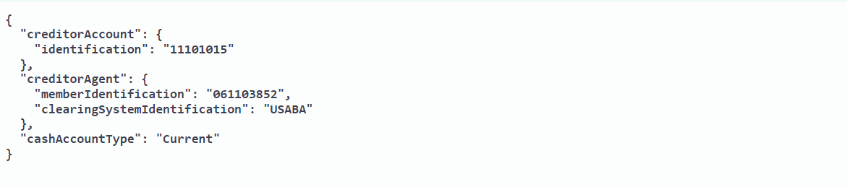

Response

A successful outcome will return a 200 – Enabled or 200 – Disabled or 200 – Unable to Locate response.

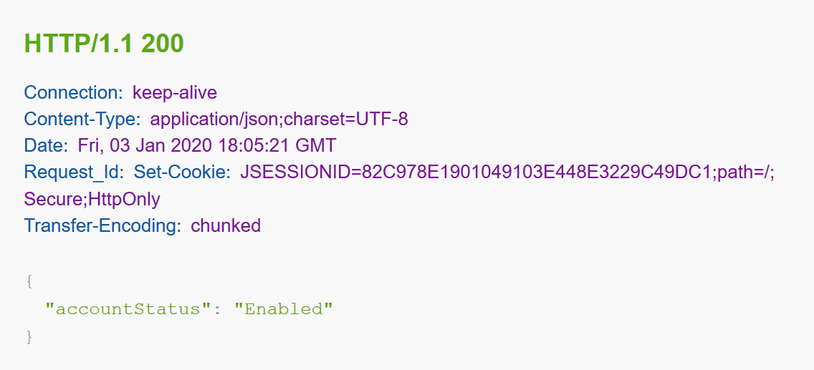

A test call that does not include one or more of the required values, or a test call that provides an invalid value (e.g., inputting the incorrect account type), will return an appropriate error response. When there is a 4XX error, additional description will help debug errors.

Example of an error response with an invalid account type:

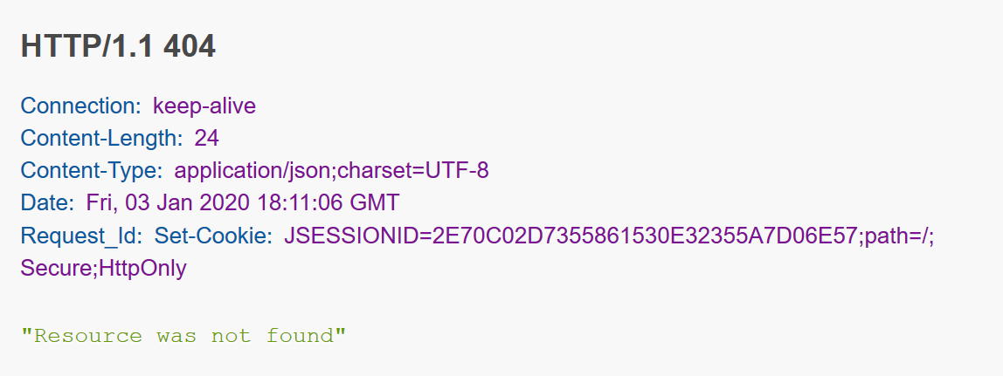

Note: If a respondent is unable to locate an account number for any reason, they have the option to use either 404 – Resource Not Found or 200 – Unable to Locate

ACH Debit Account Validation

Account Validation test data is provided below with a variety of realistic account information. This data has been preloaded into the sandbox and should all return a successful account validation outcome of 200 OK – Enabled or 200 OK – Disabled or 200 – Unable to Locate / 404 – Not Found if used correctly in the API.

Account Validation API Test Data for Debtor Account
Member Identification  [Bank ID/ABA RTN] | Creditor or Debtor identification  [Account Number] | Account Type | Account Accepts | Account Status
061103852 | 11101012 | Savings | Debits | 200-Enabled
061103852 | 11101014 | Savings | Debits | 200-Enabled
061103852 | 11101015 | Current | Credits and Debit | 200-Enabled
061103852 | 11101016 | Savings | Credits and Debits | 200-Enabled
061103852 | 11101018 | Current | Debits | 200-Disabled
061103852 | 11101019 | Savings | Credits and Debits | 404 - Not Found
NOTE: Mandatory field clearingSystemIdentification should be set to “USABA”.

Resource URL

Resource URL has been preset for each Account Validation API.

Header Parameter

An optional Request_Id may be inserted for tracing purposes.

Also, remember to set the apikey before sending the API request.

Request Body – ACH Debit

Input the relevant fields in the value tab from the sample test data provided.
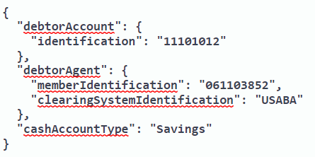

Response

A successful outcome will return a 200 – Enabled or 200 – Disabled or 200 – Unable to Locate response.

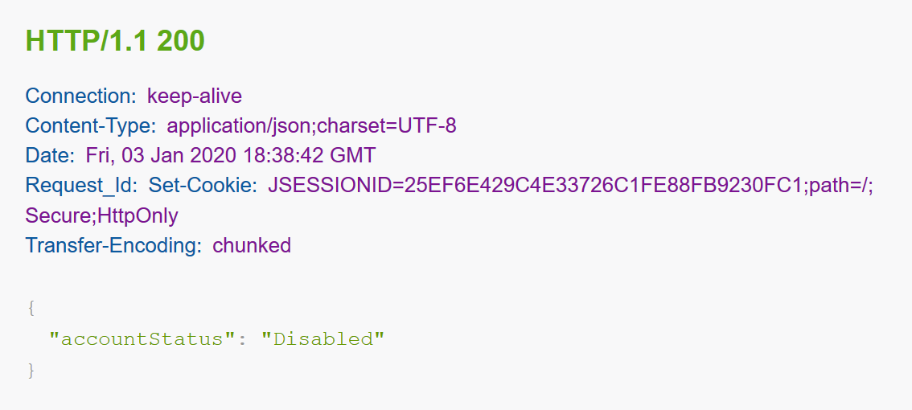

A test call that does not include one or more of the required values, or a test call that provides an invalid value (e.g., inputting the incorrect account type), will return an appropriate error response. When there is a 4XX error, additional description will help debug errors.

Example of an error response with an invalid account:

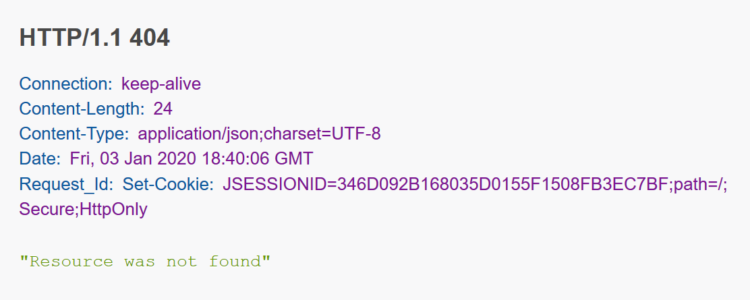

Note: If a respondent is unable to locate an account number for any reason, they have the option to use either 404 – Resource Not Found or 200 – Unable to Locate

