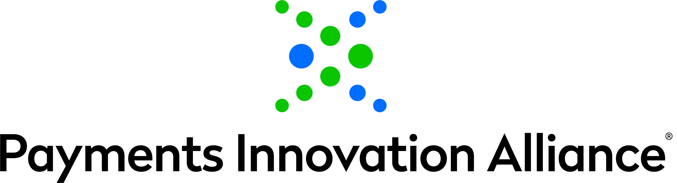

ALLIANCE ADVISORY COMMITTEES NOMINATION FORM
(Nominations Due: Wednesday, October 27, 2021 at 8:00 pm EST)

Please use a separate form for each submission

Nominee details:

Name of Nominee:

Title of Nominee:

Company:

Email Address:
Please specify Advisory Committee you are interested in (select only one):

Business Payments Advisory Committee
Consumer Payments Advisory Committee
Emerging Payments Advisory Committee
Global Payments Advisory Committee
Risk/Regulatory/Security Advisory Committee
Provide a brief overview of current job responsibilities. (no more than 120 words):

Relevant experience with Alliance activities and/or other Nacha events. (no more than 120 words)

Your Name:
Organization:
Email: |  | Date:

Please submit nominations using the attached form no later than Wednesday, October 27, 2021 to the attention of Jami Senter at Nacha jsenter@nacha.org. Please submit a separate form for each nominee. Submitters will receive a notice within 1-2 days confirming receipt of their nomination. If you do not receive confirmation of receipt of your nomination, please contact Jami Senter.

