**Account Validation**

#### 

The Account Validation API is intended to confirm that target accounts are valid so that payments can be posted as desired. Select the API product you want to test:

ACH Credit Account Validation

ACH Debit Account Validation

# **ACH Credit Account Validation**

Account Validation test data is provided below with a variety of realistic account information.  This data has been preloaded into the sandbox and should all return a successful account validation outcome of **200** **– Enabled or 200 – Disabled** **or 200 – Unable to Locate / 404 – Not Found** if used correctly in the API.

**Account Validation API Test Data for Creditor Account**

|  |  |  |  |  |
| --- | --- | --- | --- | --- |
| **Member Identification**  [Bank ID/ABA RTN] | **Creditor or Debtor identification**  [Account Number] | **Account Type** | **Account Accepts** | **Account Status** |
| 061103852 | 11101011 | Current | Credits | **200- Enabled** |
| 061103852 | 11101013 | Current | Credits | **200-Enabled** |
| 061103852 | 11101015 | Current | Credits and Debit | **200-Enabled** |
| 061103852 | 11101016 | Savings | Credits and Debits | **200-Enabled** |
| 061103852 | 11101017 | Current | Credits | **200-Disabled** |
| 061103852 | 11101019 | Savings | Credits and Debits | **404 – Not Found** |

**NOTE**: Mandatory field clearingSystemIdentification should be set to “USABA”.

**Resource URL**

Resource URL has been preset for each Account Validation API.



**Header Parameter**

An optional Request_Id may be inserted for tracing purposes.

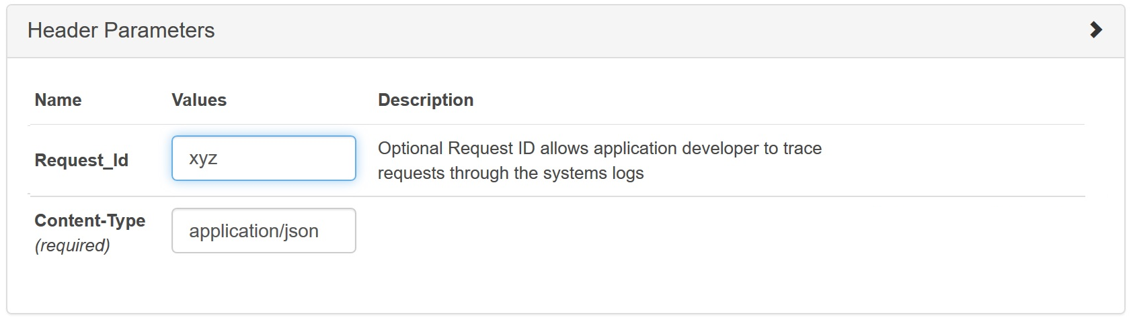

Also, remember to set the apikey before sending the API request.

**Request Body – ACH Credit**

Input the relevant fields in the value tab from the sample test data provided.

**Response**

A successful outcome will return a **200** **– Enabled or 200 – Disabled or 200 – Unable to Locate** response.

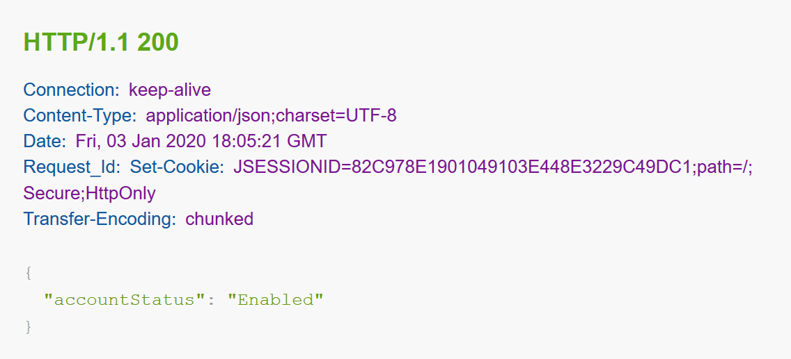

A test call that does not include one or more of the required values, or a test call that provides an invalid value (e.g., inputting the incorrect account type), will return an appropriate error response. When there is a 4XX error, additional description will help debug errors.

**Example of an error response with an invalid account type:**

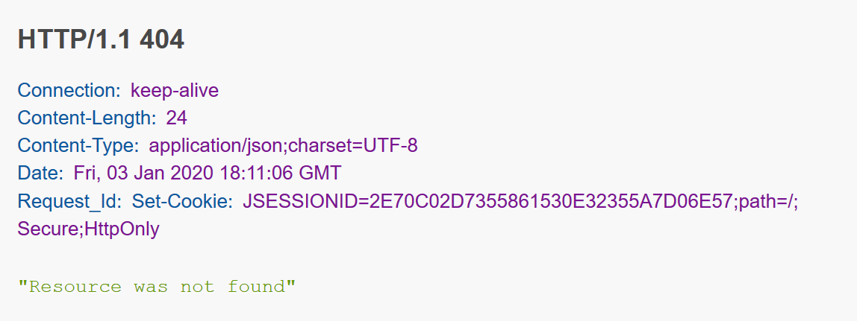

**Note: If a respondent is unable to locate an account number for any reason, they have the option to use either 404 – Resource Not Found or 200 – Unable to Locate**

# **ACH Debit Account Validation**

Account Validation test data is provided below with a variety of realistic account information.  This data has been preloaded into the sandbox and should all return a successful account validation outcome of **200** **OK – Enabled or 200 OK – Disabled or 200 – Unable to Locate / 404 – Not Found** if used correctly in the API.

**Account Validation API Test Data for Debtor Account**

|  |  |  |  |  |
| --- | --- | --- | --- | --- |
| **Member Identification**  [Bank ID/ABA RTN] | **Creditor or Debtor identification**  [Account Number] | **Account Type** | **Account Accepts** | **Account Status** |
| 061103852 | 11101012 | Savings | Debits | **200-Enabled** |
| 061103852 | 11101014 | Savings | Debits | **200-Enabled** |
| 061103852 | 11101015 | Current | Credits and Debit | **200-Enabled** |
| 061103852 | 11101016 | Savings | Credits and Debits | **200-Enabled** |
| 061103852 | 11101018 | Current | Debits | **200-Disabled** |
| 061103852 | 11101019 | Savings | Credits and Debits | **404 - Not Found** |

**NOTE**: Mandatory field clearingSystemIdentification should be set to “USABA”.

**Resource URL**

Resource URL has been preset for each Account Validation API.



**Header Parameter**

An optional Request_Id may be inserted for tracing purposes.



Also, remember to set the apikey before sending the API request.

**Request Body – ACH Debit**

Input the relevant fields in the value tab from the sample test data provided.

**Response**

A successful outcome will return a **200** **– Enabled or 200 – Disabled or 200 – Unable to Locate** response.

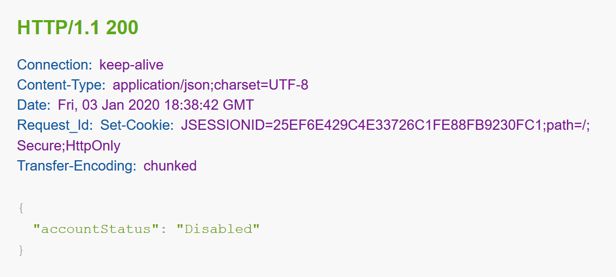

A test call that does not include one or more of the required values, or a test call that provides an invalid value (e.g., inputting the incorrect account type), will return an appropriate error response. When there is a 4XX error, additional description will help debug errors.

**Example of an error response with an invalid account:**

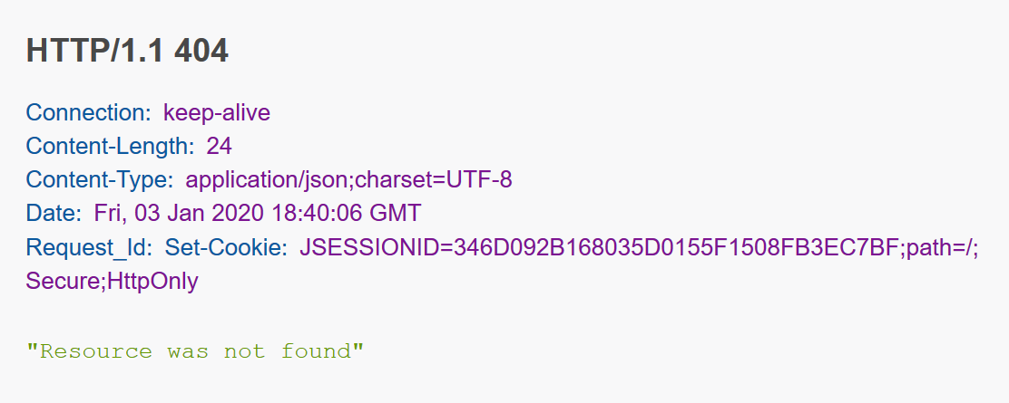

**Note: If a respondent is unable to locate an account number for any reason, they have the option to use either 404 – Resource Not Found or 200 – Unable to Locate**